
IW-14
YEAR 7 SCIENCE
EARTH & SPACE SCIENCES
TEST 1 - THE EARTH AND MOON

NAME: CLASS: MARK: 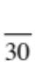

Achievement standards being tested
Predictable phenomena on Earth, including seasons and eclipses, are caused by the relative positions of the Sun, Earth and the Moon.

Mark | ND | NW | C | HC | O
Mark Range | 0-8 | 9-14 | 15-18 | 19-21 | 22-30

Multiple Choice Write the answer to each question in the appropriate box at right.

1. The main cause of day and night is:
QUESTION | ANSWER
1
2
3
4
5
6
7
8
9

A rotation of the Earth.
B revolution of the Earth.
C orbit of the Earth.
D the tilt of the Earth on its axis.

2. The diagram below relates to which season in Australia?
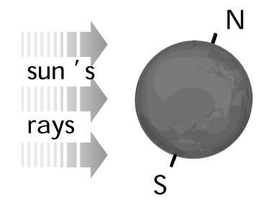
A Winter
B Spring
C Summer
D Autumn

3. The Moon, stars, planets and the Sun all rise in the:

A west.
B north.
C south.
D east.

4. Which of the following is correct?

A The rotation of the moon allows us to view most parts of its surface at various times.
B The moon does not rotate on its axis, so we see only one side of it.
C The moon rotates on its axis once in the time it orbits the Earth, so we always see the same side.
D The moon is too far from Earth to be able to distinguish which side is facing us.

5. The different shapes of the Moon as seen from Earth are called:

A stages.
B phases.
C fractions.
D crescents.

6. The time taken for the moon to orbit the Earth once is closest to:

A 24 hours.
B 14 days.
C 27 days.
D 365 days.

7. The force that causes high and low tides on Earth is:

A friction.
B gravity.
C electric.
D magnetic.

8. Which of these has the greatest effect on the tides on Earth?

A Mars
B Venus
C The Moon
D The Sun

9. Only one face of the moon is visible from Earth. This is because:

A Earth and moon rotate at the same rate.
B the moon does not rotate and thus only presents one area facing Earth.
C there is no change from day to day of the moon's position relative to Earth.
D the moon's period of rotation equals its period of revolution around Earth.

Short Answer Write the answer to the questions in the spaces provided.

1. Choose the correct definition for the term in the first column of the table below. Write the correct letter in the second column.

TERM | CORRECT LETTER | DEFINITION
Rotation |  | A: Describes the Earth's movement around the  Sun.
New moon |  | B: When the whole of the Moon's surface has  sunlight reflected from it.
Tides |  | C: When the Moon passes into the Earth's  shadow.
Lunar eclipse |  | D: Caused by the gravity of the Moon.
Revolution |  | E: Causes the Earth to have night and day.
Full moon |  | F: When the Moon passes across the Sun.
Solar eclipse |  | G: When no light is reflected from the Moon.

(7)

2. Sketch the shape of:

(a) a crescent moon

(b) a gibbous moon

(c) a full moon.

(3)

3. On the diagram below, show where a full moon, new moon , the first-quarter and
third- quarter moons occur.
(2)

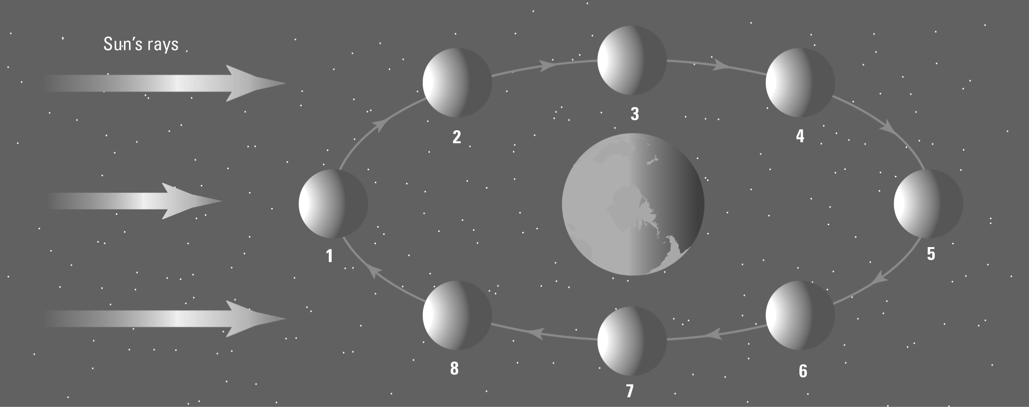

4. Look at the diagram below, which shows the Earth "tilted" with respect to its path around the
Sun.

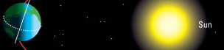

(a) For Australia, which is in the southern hemisphere, does the diagram show us having
summer or winter?

(1)

(b) Explain your answer briefly.

(2)

(c) In which months would this season occur in Australia?

(1)

5. Draw a diagram of a lunar eclipse, showing the position of the Sun, Moon and Earth. Include rays to show the path of the sunlight.

(2)

6. (a) When the full Moon is overhead in Australia, which type of tide is experienced?

(1)
(b) Explain carefully why this tide occurs.

(2)

